# Interpret a Data Visualization

Submitted by: Saifeldin Ahmed

## Insights:

### Not a single country has all globally ranked skills in their top 10 skills.

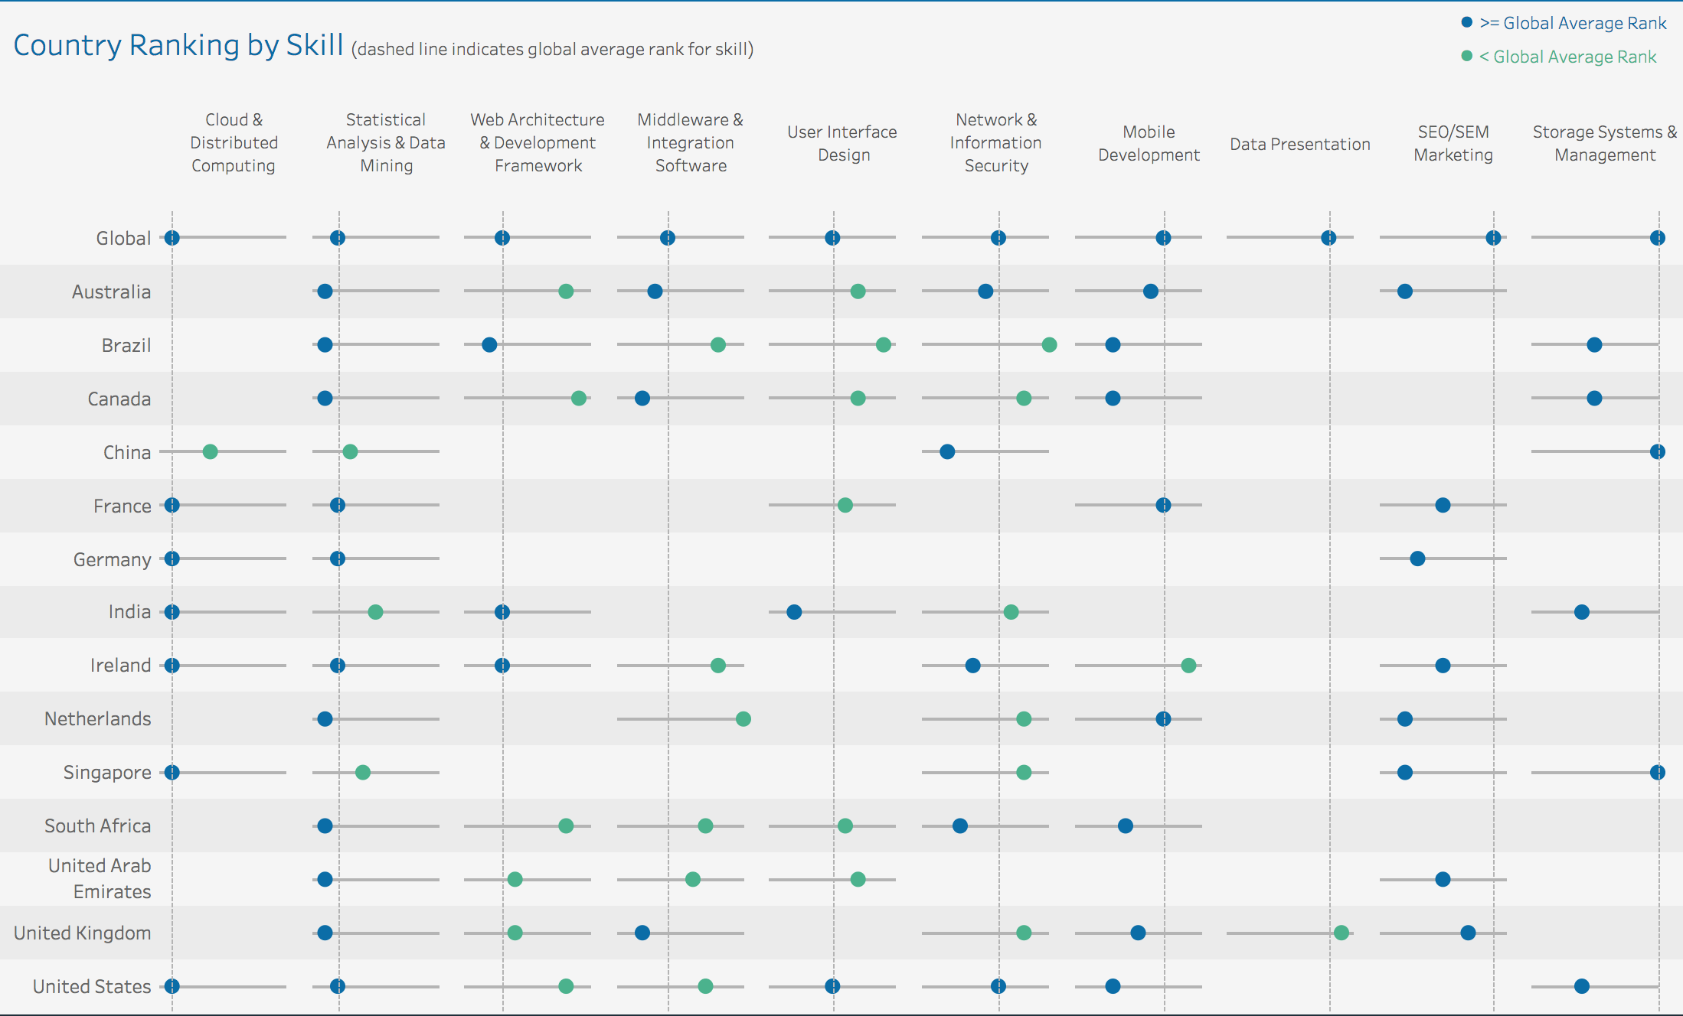

By having a look at the dashboard, we see that there isn’t once country that has all 10 skills which are ranked globally in their top 10 skills. This indicates the diversity of skills across different countries.

### United States is most aligned with global skills ranking

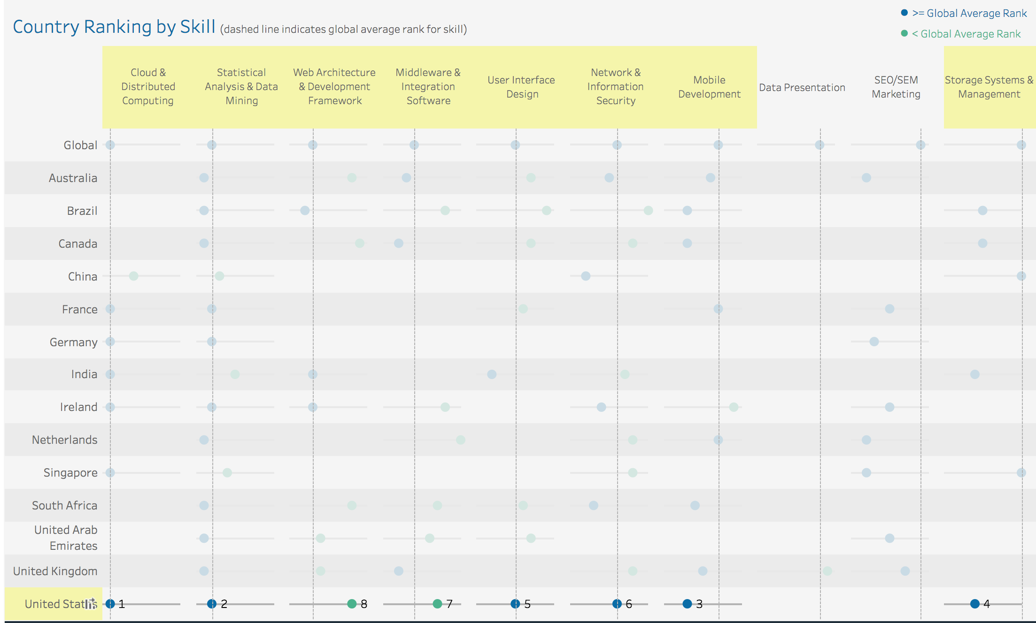

By hovering over the United States row, we see that 8 out of 10 skills are present in the US rankings. This is more than any other country listed. This might be because of bias in the data (having more LinkedIn users from US compared to other countries)

### Data Presentation

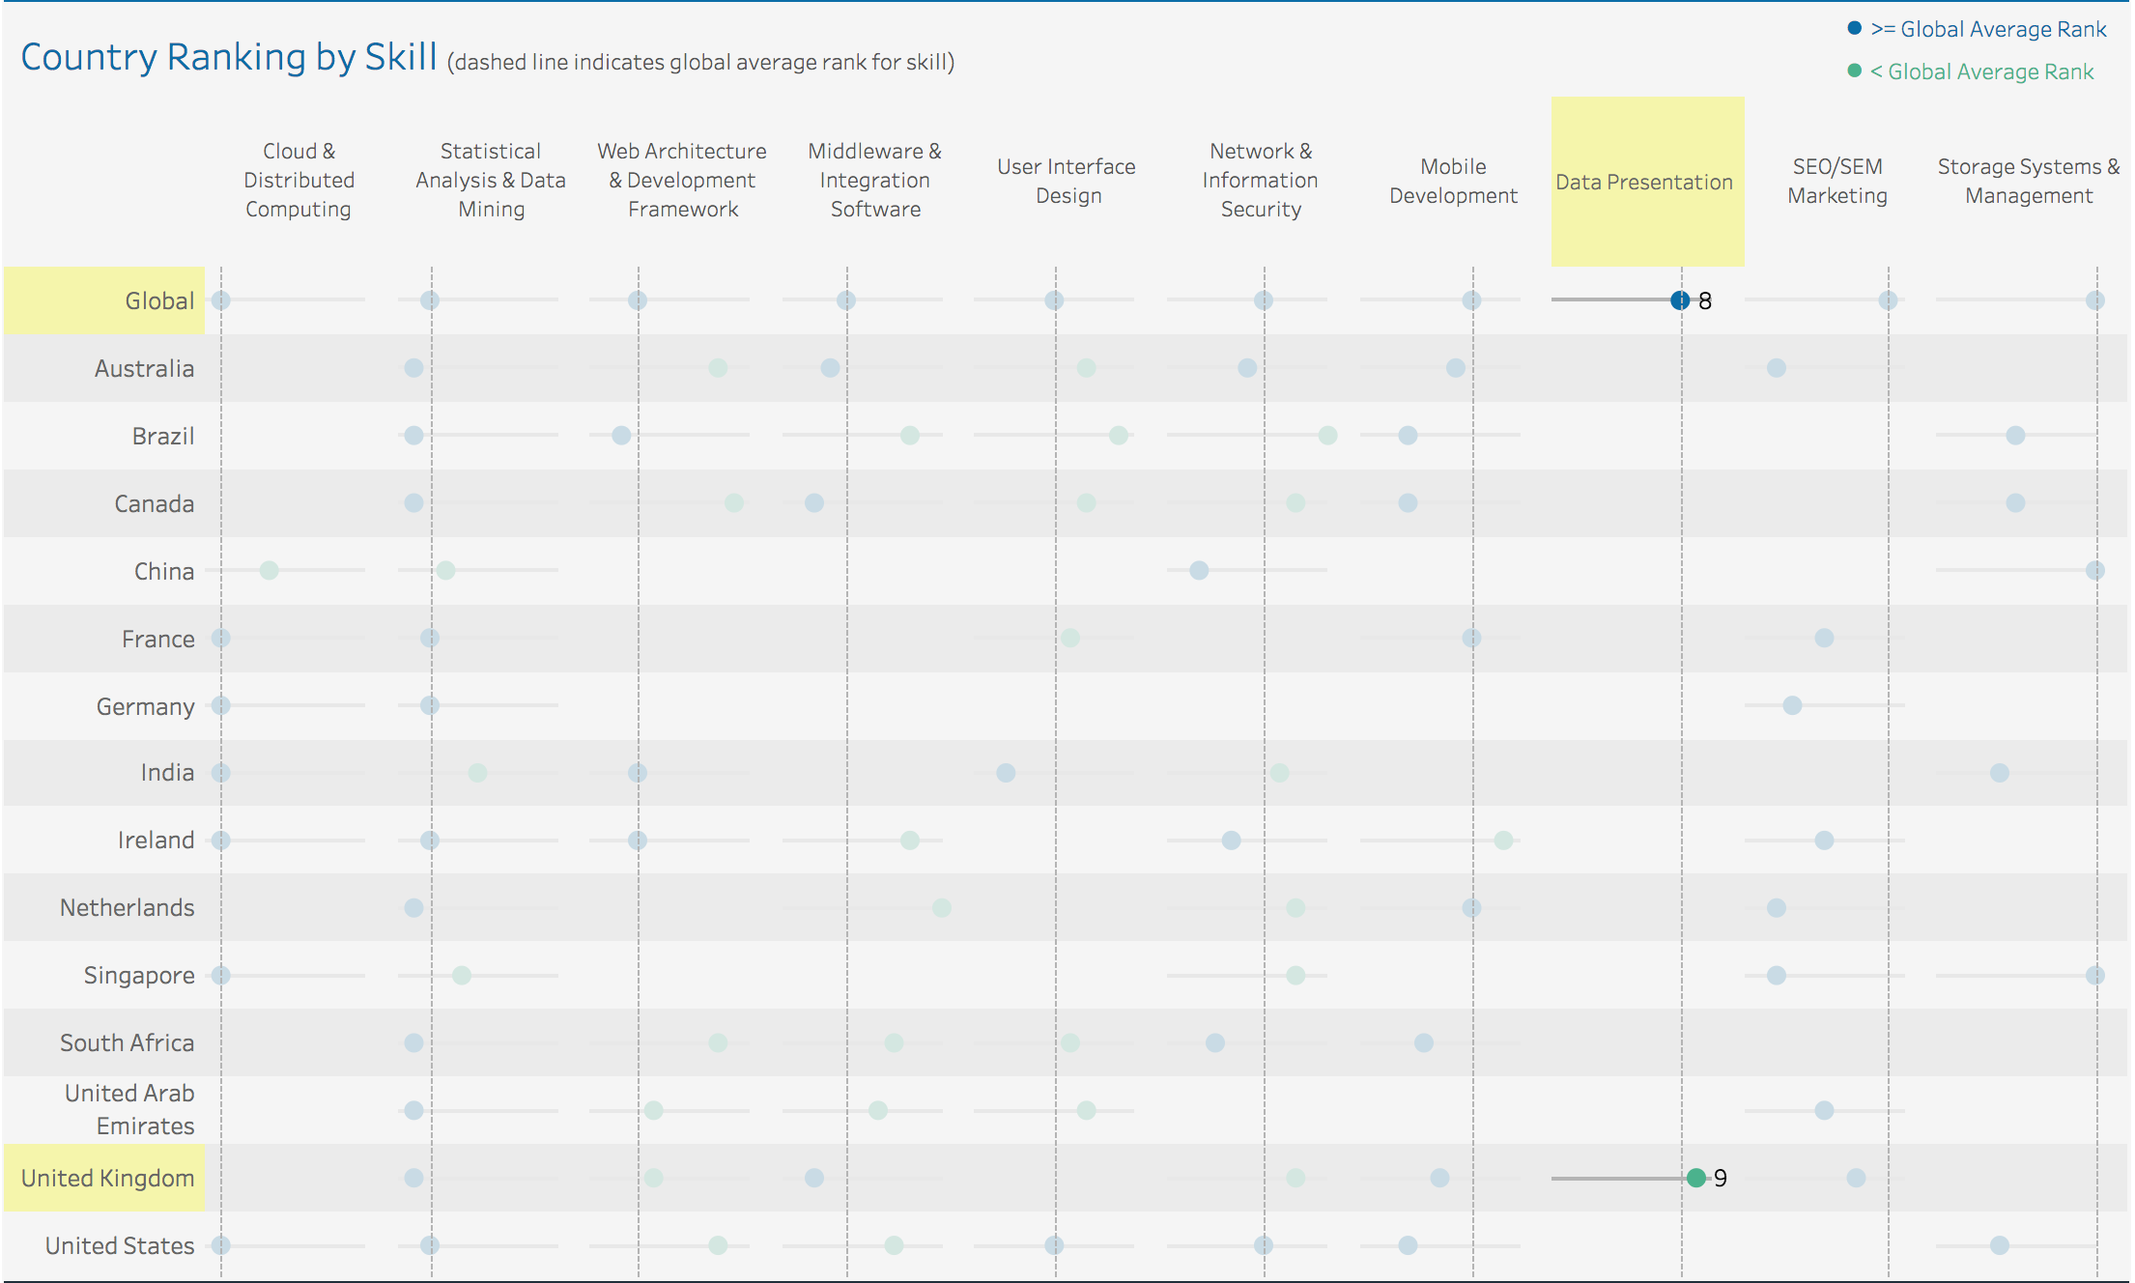

By hovering over Data Presentation, we see that it is ranked 8th globally and 9th in UK. The interesting thing to note here is that this skill is only present in the UK rankings where is has a ranking lower than the Global Ranking. This could indicate that there are other countries which are not listed here which boost this skill’s global ranking.

### Statistical Analysis and Data Mining is the only skill present in the top 10 ranking for all listed countries

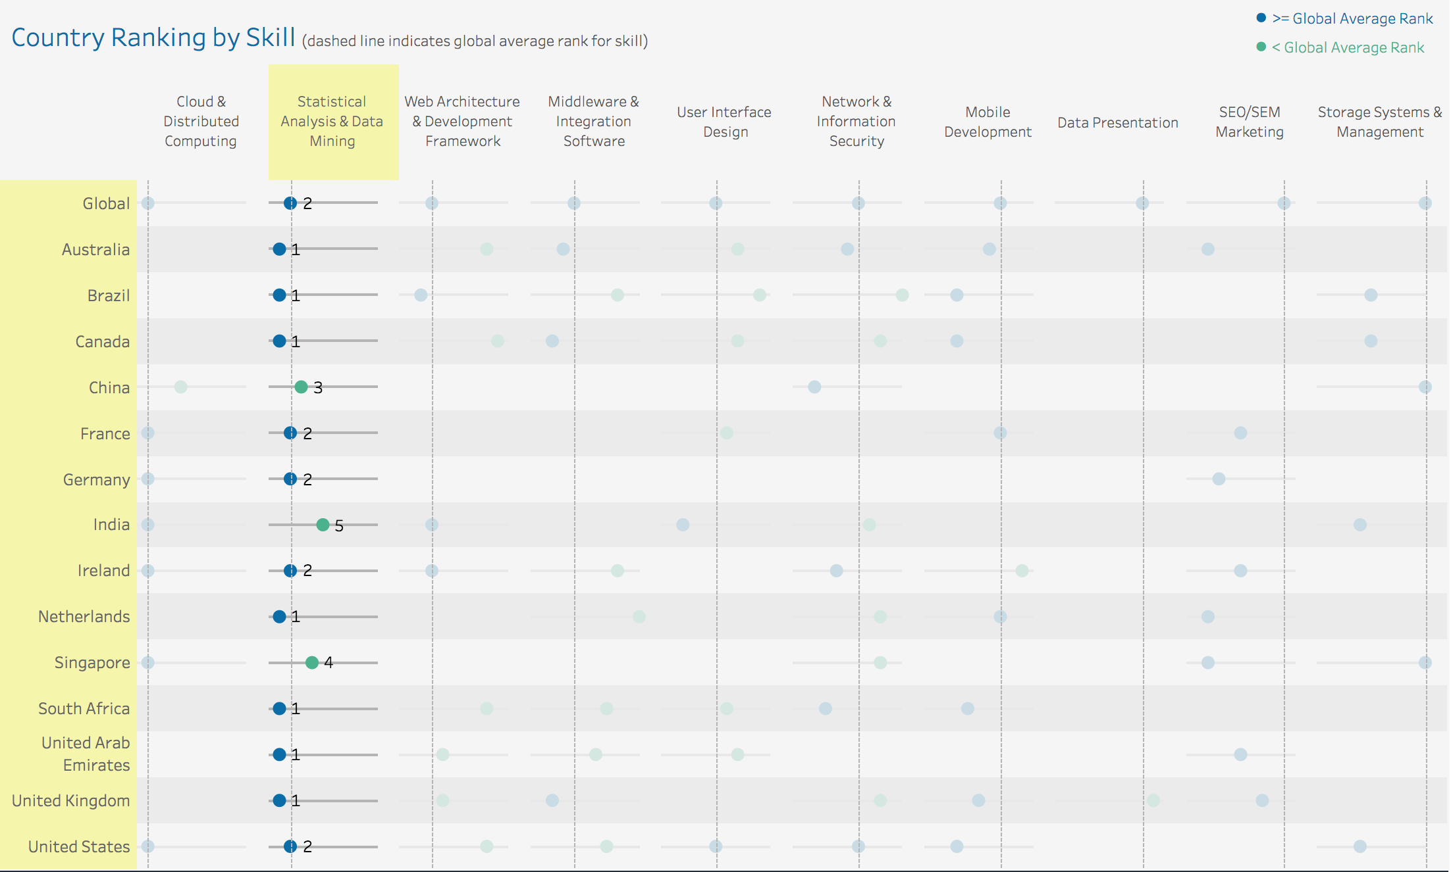

By hovering over the Statistical Analysis and Data Mining skill, we see that is has a high ranking in all listed countries.

### Cloud & Distributed Computing is ranked first in all countries except China

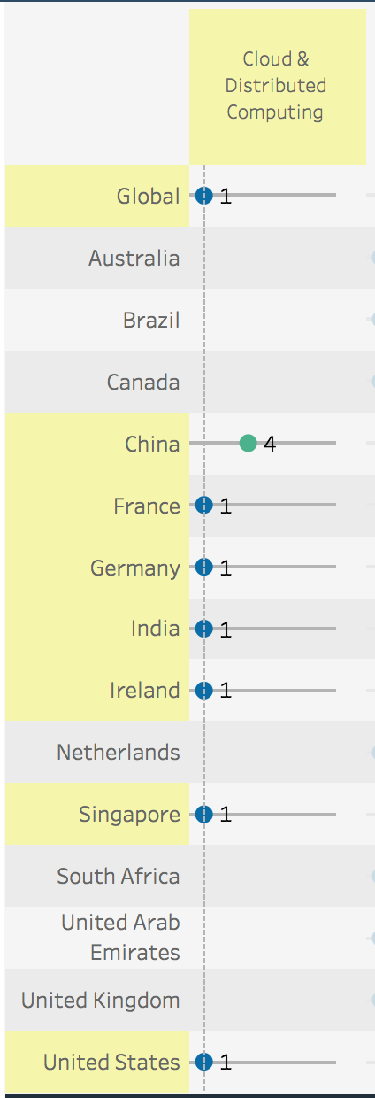By hovering over Cloud & Distributed Computing we see that it is ranked 1st in 6 countries out of 7 with China being the only exception. Yet, this skill is still ranked the 1st skill globally. This could mean that a significant number of users from France, Germany, India, Ireland, Singapore, and US have this skill thus boosting it to #1 globally.